Lumpers or splitters? that is the question - evaluating recovery and management plans for metapopulations of herring.

L.T. Kell¹, R.D.M. Nash², M. Dickey-Collas³, G.M. Pilling¹ & B.A. Roel¹

¹Cefas, Lowestoft Laboratory, Pakefield Road, Lowestoft, Suffolk, NR33 0HT, UK ²Institute of Marine Research, PO Box 1870 Nordnes, 5817 Bergen, Norway ³Wageningen IMARES, P.O. Box 68, 1970 AB Ijmuiden, The Netherlands

Abstract

We evaluate long-term management of metapopulations through simulations for a case study based loosely upon herring to the west of the British Isles. These stocks are currently assessed and managed by management area, although there is evidence of much mixing between stocks (in terms of connectivity, migrations and exploitation). The simulations test the sustainability of fishing under two hypotheses corresponding to either discrete stocks which only mix on the feeding grounds, or where diffusion between stocks takes place, and where the assessment process assumes either discrete stocks or one metapopulation.

Introduction

A key concept in fisheries science and management is that of the stock, defined as the aggregate of a population that can be managed as a discrete unit (Quinn and Deriso, 1999). Such a definition implies that a stock is isolated from other stocks of the same species, is self-sustaining, and that catches can be recorded and regulated by that stock alone. However, Waples and Gaggiotti (2006) in a review entitled “What is a Population?” concluded that no consensus has yet emerged regarding a quantitative definition of a stock or population. Instead we have to rely on qualitative descriptions such as "a group of organisms of the same species occupying a particular space at a particular time" (Krebs, 1994). This means that management advice based upon total allowable catches from a stock that is defined operationally by a fishery, rather than biological understanding, may have unforeseen ecological and evolutionary impacts. This is because fisheries may catch fish from aggregations of mixed origin (stocks or components) and resulting data can therefore confound classic stock assessment methods. Waples and Gaggiotti (2006) also noted, however, that the lack of any quantitative definition is not necessarily a fatal problem, since depending on the context and underlying objectives, a variety of criteria could be appropriate.
Therefore in this study we evaluate the consequences for stock assessment of defining stocks on fisheries rather than on the spawning population, through a case study loosely based upon herring stocks to the west of the British Isles. Herring along the west of the British Isles are currently managed as four separate stocks (i.e. West of Scotland (VIaN), west of Ireland (VIaS), Irish Sea (VIIaN) and Celtic Sea (see ICES 2008)). There are also smaller spawning populations, such as the Clyde, which are not now regularly assessed although they supported significant fisheries in the past.
Historically herring stocks to the west of the British Isles are defined by location and “spawner types” (i.e. spawning time in autumn, winter or spring), and many areas support populations that spawn in different seasons (Mitchell, 1864; Samuel, 1918; Parrish and Saville, 1965). The main summer feeding aggregations of these stocks are on the Malin-Hebridian Shelf and in the Celtic Sea (Parrish and Saville, 1965; Figure 1). Historically, fisheries to the west of the British Isles have targeted these aggregations of feeding fish, and catches from these aggregations have been apportioned to stocks on the basis of the ICES Management Area in which they were caught.

Figure 1 about here

Since the early 1990s conflicting trends have been seen in the herring stocks to the west of the British Isles, within and between catch and survey data.. These problems have been exacerbated by apparent changes in the productivity of stocks (Simmonds and Keltz, 2007). In turn, management measures have failed to prevent over exploitation (ICES, 1994, 2008; Molloy, 2006), while the definitions of assessment and management units (i.e. the stocks) have changed frequently since assessments began (ICES, 1994; Molloy, 2006). A recent EU funded project (WESTHER) found that population/stock structure of these herring stocks was complex, and that fisheries and management were not based upon discrete populations in some areas (Mackenzie, 1985; Brophy et al., 2006; Campbell et al., 2007).
To develop management plans that cam maintain seperate spawning component in a healthy state for fisheries that exploit multiple spawning components we need to evaluate whether the currently used stock assessment methods can detect changes in F, SSB and recruitment. We also need to correctly identify the causes of these changes, i.e. to distinguish between changes in F and regime shifts In addition, we evaluate whether practical options can improve management by examining the impact on the assessment of survey timing, and of lumping together or splitting apart data from different stocks within the assessment process.
Therefore in this study we demonstrate a simulation framework which can be used to investigate consequences of the existence of metapopulations and of implementing management on that basis, or of being unaware of the true population demography. This also evaluated our ability to provide robust advice on limits to exploitation and targets based upon maximum sustainable yield using alternative assessment procedures. These were i) synoptic surveys at spawning or feeding time and ii) a combined assessment of stocks (lumping). In addition, we evaluate the impact of regime shifts on the perception of the stock and consequences of differential levels of exploitation across stocks for alternative plausible mixing hypotheses.

Material and Methods

To avoid confusion, the term population is used here to refer to the spawning units and the stock to the assessed stock, i.e. as defined by catches from the fisheries.
The FLR framework (Kell et al. 2007, www.flr-project.org) for management strategy evaluation (MSE) was used to build an operating model (OM) that can represent alternative hypotheses about stock and fishery dynamics, allowing a higher level of complexity and knowledge than used by stock assessment models. An observation error model is then used to sample pseudo-data from the OM and a stock assessment and management procedure to derives estimates of stock status from the pseudo data.
Four populations were constructed on the basis of their spawning behaviour, while four fisheries occur during the feeding migrations when the spawning populations overlap to different extents. This is represented diagrammatically in Figure 2 where green circles represent spawning aggregation and dotted areas show the overlaps during feeding times. This ‘generic’ configuration is slightly different from the herring population configuration to the west of the British Isles. This allows us to contrast an ‘isolated population’ (population 4) with ones that have varying degrees of connectivity.

Figure 2 about here

There is also some limited diffusion between the spawning populations giving two alternative hypotheses with respect to mixing, i.e.:
- Overlap; there are four distinct populations and the only interaction is via the fishery or
- Diffusion; a proportion of population i moves to population j each year and contributes recruits in the future based on the stock recruitment relationship of stock j.
The mixing matrix is given in Table 1 and the diffusion matrix in Table 2.

Tables 1 and 2 about here

Time series of catch, numbers and fishing mortality-at-age and life history traits are loosely based upon the four herring stocks to the west of the British Isles that are currently assessed by ICES (see ICES 2008). Life history traits for the population were:
- annual spawning (1 cohort per year) with populations 1 & 3 spawning in autumn and populations 2 & 4 spawning in winter/spring.
- Proportion mature at age.
 | Age
Population | 1 | 2 | 3 | 4 | >=5
1 | 0.1 | 0.5 | 0.8 | 1.0 | 1.0
2 | 0.1 | 0.5 | 0.8 | 1.0 | 1.0
3 | 0.2 | 0.7 | 0.8 | 1.0 | 1.0
4 | 0.2 | 0.7 | 0.8 | 1.0 | 1.0
- fecundity is linearly proportional to weight,
- growth as used in the assessments (ICES 2008)
- lifespan of 7 years.
- age-specific, but time-invariant, natural mortality as used by ICES, i.e., M=1.0 for age 1, M=0.3 for age 2, M=0.2 for age 3, and M=0.1 for all other ages.

The four fisheries operate in particular areas and seasons, which determine the availability of a population to a fishery (see Table 1). Given the selection pattern (S) of a fishery and the catchability (q) of a population for a given effort (E) the fishing mortality at age a, for year y, fishery i and population j is given by
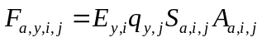 (1)
Where A_{a,i,j} is the availability of population j at age a to fishery i.

The population abundance at age a+1, at the start of year y+1, in population j, is given by:
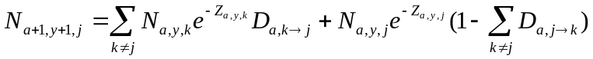 (2)

where Z_{a,y,j} and Z_{a,y,k} correspond to the total mortality at age a, by year y and populations j and k respectively, 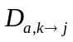corresponds to the diffusion proportion of population k into j at age a, and 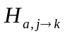 is the equivalent from population j into k. We assume that diffusion occurs just after the start of the year, followed by mortality.
A Beverton and Holt (1957) stock/recruitment relationship was assumed:
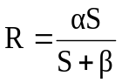 (3)
where R is the level of recruitment, S the spawning stock biomass, and α and β are estimated stock-specific parameters. The formulation of Francis (1992) was used to re-parameterise the relationship (for given natural mortality, mass and maturity-at-age) in terms of steepness (τ) and virgin biomass (γ). Steepness is the fraction of the virgin recruitment (R₀) expected when the spawning stock biomass (S) has been reduced to 20% of its maximum, (i.e., R = τR₀ when S = γ/5), and represents the resilience of the stock to exploitation:
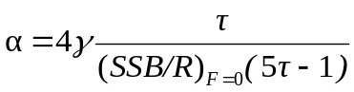 (4)

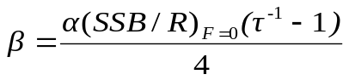 (5)

Parameters were estimated from the stock and recruitment data for each population, fits are shown in figure 3. Unconstrained fits of both Beverton and Holt and Ricker functional forms were similar, but implausible, resulting in increasing recruits with stock biomass. Therefore a Beverton and Holt relationship was fitted to the data assuming a fixed plausible value of steepness (0.75). Sensitivity analyses were performed assuming an alternative plausible value for steepness of 0.9. These indicated that results from the simulations were qualitatively the same for all values explored, the only differences being in absolute levels of fishing mortality at which MSY was achieved and the stock was driven to extinction (F_{Crash}). Therefore, only results corresponding to a steepness of 0.75 are presented.

Figure 3 about here

The target (MSY, B_{MSY} and F_{MSY}) and limit (F_{Crash}) reference points for the four populations for steepness = 0.75 are given in Table 3.

Table 3 about here

The stock assessment procedure
The stock assessment procedure combined a particular sampling regime and stock assessment technique. The sampling regime - the “Observation Error Model” - is simulated by generating total catch-at-age and indices of abundance from the simulated fisheries and populations. Timing of the indices of abundance was either i) during spawning, or ii) during fishing. The former represents an unbiased estimate of the spawning population; the latter is an index of abundance of the stocks caught in each fishing area (i.e. at the time of mixing). In both cases a single series that covered all the age ranges in the population was constructed assuming a log normal observation error with a CV of 30%.
A single assessment method (XSA; Shepherd, 1999) based upon Virtual Population Analysis (VPA), was used to estimate fishing mortality and numbers-at-age in the population, conditional on the assumed values of natural mortality and reported catch-at-age. The indices of abundance were used to calibrate the VPA in the management procedure. VPA estimates numbers and fishing mortality-at-age working backwards down a cohort given an estimate of the fishing mortalities of the oldest ages in a cohort (i.e. terminal fishing mortalities). The errors in these estimates at earlier ages become progressively less sensitive to the assumed terminal fishing mortalities used to initiate the calculations (Pope and Shepherd 1982). The terminal Fs are estimated using the indices of abundance where the relationship between number-at-age and the index is assumed to include measurement and process error while the catch-at-age is assumed to be exact. This means that older ages have the largest errors, the least being on the recruiting age classes. Estimates of SSB are dominated by ages 2 to 4 because of the observed survival, the mass-at-age, and because of the selection pattern which results in higher fishing mortality on the older ages.
Scenarios
In order to evaluate whether we are able to detect and correctly identify the causes of changes in F, SSB and recruitment, a variety of scenarios were considered for the fisheries and populations. This allowed the perception of the stock (resulting from the stock assessment) and the status of the true population to be contrasted. The scenarios were:
  - Constant fishing mortality in all fisheries
  - A one off increase in fishing mortality in a single fishery
  - Regime shifts
  - Diffusion between populations

Regime shifts were modelled by a 60% decrease in productivity as measured by MSY. Two options were considered, being either due to a change in either F_{MSY} or B_{MSY}.

All scenarios were examined under the following assessment options:
- Performing separate assessments by fishery (splitting) or combining catches over fisheries (lumping); and,
- Indices of abundance conducted at either time of spawning or time of the fishery.

Only selected scenarios are presented to illustrate the behaviour of the framework. Scenarios considered are presented on Table 4.

Table 4 about here

Results

Initially, to understand the behaviour of simulations, a relatively simple scenario (scenario 1) is presented in figure 4. In this scenario, fishing mortality is held constant within a fishery, in order to easily interpret the effects of mixing. Columns correspond to time series of fishing mortality, recruits, SSB and yield. Rows correspond to the population/stock, as defined in figure 2. The behaviour when the population and stock definitions correspond, i.e. when the population is only exploited by a single fishery, can be seen by reference to population/stock 4 (fourth row). Yields are known exactly, and so fishing mortality and recruitment is well estimated. Although estimates of SSB are noisier than the true values, there is no strong bias. This is because catch-at-age is known exactly and the survey provides an unbiased estimate of the population.
For populations/stocks 1, 2 and 3, where there is mixing between spawning populations at the time of the fisheries catches from a spawning population occur across multiple feeding or fisheries areas. For populations/stocks 1 and 2 there is a net inflow in biomass at the time of the fishery, while for population/stock 3 there is a net outflow. This is reflected in catches in those fisheries, and corresponding estimates of SSB and recruits. However, although bias is also seen in fishing mortality the sign of the bias is not as consistent as it was for yield, recruitment and SSB. Fishing mortality is the log ratio of catch at successive ages in a cohort. Therefore if fishing mortality is estimated from the combined catches of two stocks with the same productivity, year-class strengths and selection patterns, but where exploitation levels differ, fishing mortality will be biased towards that in the stock from which the greatest catch is taken. Since catches will be greatest from the stock exploited nearest to F_{MSY}, the bias in fishing mortality will be in the direction of F_{MSY}. For example in an extreme case where one stock is heavily overexploited and one is exploited at MSY, catches will be relatively larger from the stock exploited at F_{MSY} and so the estimate of fishing mortality will be close to F_{MSY}. As a result, it will markedly underestimate F in the overexploited population.
In the subsequent analyses results from a selected number of scenarios (table 4) are presented in order to illustrate the utility of the framework. Since yield and recruitment are strongly correlated with SSB, only results for SSB and fishing mortality are presented in figures 5 and 6 respectively.
The treatment in scenario 2 is an increase in fishing mortality in 2025 for fishery 1. While in scenarios 3, 4 and 5, a regime shift occurs in spawning population 1 which simulates a 60% decrease in productivity (i.e. a 60% decrease in MSY).This is modelled in scenarios 3 and 4 as a reduction in the resilience of the stock (i.e. F_{MSY} declines but B_{MSY} remains unaltered) and in scenario 5 as a reduction in carrying capacity (i.e. B_{MSY} declines but F_{MSY} remains the same). The difference between scenarios 3 and 4 is that in scenario 4 there is also diffusion between the spawning populations.
The effects on SSB is are similar reduction in spawning population 1 under scenarios 2 and 3, although the causes are quite different (i.e an increase in F and a decrease in F_{MSY}). Under scenario 5 a reduction in SSB is also seen while in scenario 4 (where diffusion occurs) the reduction is greatly diminished compared to scenario 3. The declines in SSB are tracked by the assessment in fishery 1 data. However in the assessment of data from fishery 2 a decline is perceived in SSB even though no decline has been seen in the spawning population. Similarly when combining the data from the fishery declines in SSB are perceived.
The corresponding results for fishing mortality are presented in figure 6, the main effect is that the bias in estimates of fishing mortality is in the direction of F_{MSY} as seen in figure 4. The main effects is seen in scenarios 2 and 3. In scenario 2 after the initial increase, there is an apparent decline in F as population 1 becomes depleted, and the proportion of catches in fishery 1 actually from population 1 declines. A similar effect is also seen in population 2, where an apparent (but erroneous) increase and subsequent decline is perceived. In the combined stock assessment of populations 1 & 2, initially F is overestimated then as F increases it is underestimated and there is also a perceived decline.
The timing of the survey influences the F estimates but not those of SSB, when separate assessments of the stocks are conducted. The effect of conducting a survey at the time of the fishery is to induce a “retrospective” bias. In the case of population/stock 1, the “bias” would actually be closer to the truth. In the case of population/stock 2, the bias underestimates the true level of exploitation.
In scenario 3 where resilience of the stock changes (i.e. MSY and FMSY), if the survey is conducted at the time of the fishery there is a perceived increase in fishing mortality. While when 10both the true and perceived populations are combined both the true fishing mortality and the estimates show an increase, even though F in both populations has been constant.
In scenario 4 where the carrying capacity of the stock changes (i.e. MSY and B_{MSY}), bias is the same as in scenario 1 when fishing mortality was constant. The regime shift is not interpreted as a change in F, although a slight increase in F in the combined population is seen, which is not picked up by the assessment. Timing of the surveys has no effect.
Discussion

Preserving the spatial structure of a population can be important in maintaining its ability to sustain variable environmental conditions (Hilborn, 2003) since maintaining a broad spatial distribution of spawning and recruitment is at least as important as spawning biomass in maintaining long-term sustainable levels (Berkeley et al., 2004). However, the results show that assessments based upon VPA alone might not be able to detect when an individual spawning component is being over exploited. Differential exploitation of spawning components may mean that recruitment dynamics are different during recovery and collapse stages. For example Nash et al. (in press) compared the recruitment dynamics of North Sea herring during and after severe exploitation, and found more variability in recruits per unit spawning stock size when the stock was smaller and concluded that this was probably a result of the potential larger diversity in contributions from spawning components in an unexploited stock compared to an overexploited stock.
Although this study is only loosely based upon western herring stocks, it has raised a number of key points that can be transferred. It is clear that the different management options required to reduce uncertainty, i.e.: i) improving biological knowledge by scientific study and hypothesis testing; ii) improve data collection by conducting surveys or disaggregating catches on appropriate temporal and spatial scales; or iii) by developing robust management procedures, i.e. reducing the dependency on knowledge, need to be evaluated. The last of these in particular is an important but difficult challenge.
For example assessment methods based upon surveys alone could be used as an alternative to fishery based methods (Trenkle ) however before these can be used to provide management advice they should be fully evaluated in the form of a management procedure (that combines the data collection regimes and the algorithms or rules used to provide management advice) that is tested against a variety of plausible hypotheses and the true dynamics of the stocks and fisheries (e.g. as done by De Oliveira and Butterworth, 2004 in developing a survey based rule for management of the sardine and anchovy fishery is South Africa). In this regard an important area in which the framework can also be used will be in identifying the relative costs and benefits of the available management options, which essentially will include the benefits of scientific knowledge.
Although in this study we haven’t answered the question posed at the beginning i.e. whether to lump or split, the framework developed in this study will be an important tool in identifying how biological knowledge can be better incorporated into stock assessment in order to meet management objectives and in particular where effort needs to be directed to develop robust alterative to the current VPA orthodoxy.
It might be of course that the effects identified in this study are minor compared to other effects, that the mixing hypotheses are wrong, or the ability of stocks to recolonise depleted areas means that the findings from a limited study of this type are largely irrelevant. However, it would be good to know if that is the case and if there are other major concerns, what those concerns are. Such questions can of course be partly addressed by considering additional biological hypotheses within such a framework, especially if biologists can provide appropriate probabilities for any hypotheses.
The results of this study are important not just for herring stock assessment and management advice but for stock assessment generally since, for many stocks assessed by VPA and managed by TAC, all catches are assumed to come from one homogeneous population with no migration into or out of the stock area. However, it is known that many stocks have separate spawning components covered by a management area but that this is ignored in practice. The framework used within this study will be an important tool to evaluate the robustness of current and alternative management measures to ensure that the stocks are not overexploited and that fisheries can be managed consistent with commitments under agreements such as the World Summit on Sustainable Development to recover stocks to a level that can support MSY by 2015.

References

Beverton, R. J. H., and Holt, S. J. 1957. On the dynamics of exploited fish populations. Fisheries Investigations Series 2, 19. Ministry of Agriculture, Fisheries and Food, G.B.
Brophy, D., Danilowicz, B.S., and King, P.A. 2006. Spawning season fidelity in sympatric populations of Atlantic herring (Clupea harengus). Can. J. Fish. Aquat. Sci. 63(3): 607-616. doi:10.1139/F05-235
Campbell, N., Cross, M.A., Chubb, J.C., Cunningham, C.O., Hatfield, E.M.C., and MacKenzie, K. 2007. Spatial and temporal variations in parasite prevalence and infracommunity structure in herring (Clupea harengus L.) caught to the west of the British Isles and in the North and Baltic Seas: implications for fisheries science. J. Helminth. 81(2): 137-146. doi: 10.1017/S0022149X07747454.
De Oliveira, J.A.A. and D.S. Butterworth 2004 – Developing and refining a joint management procedure for the multispecies South African pelagic fishery. ICES J. mar. Sci. 61: 1432-1442.
Francis, R. I. C. C. 1992. Use of risk analysis to assess fishery management strategies: a case study using orange roughy (Hoplostethus atlanticus) on the Chatham Rise, New Zealand. Canadian Journal of Fisheries and Aquatic Sciences 49: 922–930.
ICES, 1994. Report of the Study Group on Herring assessment and Biology in the Irish Sea and Adjacent Waters. ICES CM 1994/H:5.
ICES, 2008. Report of the Herring Assessment Working Group South of 62oN (HAWG). ICES CM 2008/ACOM:02.
Krebs CJ (1994) Ecology: The Experimental Analysis of Distribution and Abundance. Harper Collins, New York.
MacKenzie, K. 1985. The Use of Parasites as Biological Tags in Population Studies of Herring (Clupea harengus L) in the North-Sea and to the North and West of Scotland. J. Cons. int. Perm. expl. Mer. 42(1): 33-64. doi:10.1093/icesjms/42.1.33.
Molloy, J. 2006. The herring fisheries of Ireland (1900-2005). Biology, Research, Development and Assessment. Marine Institute, Galway, Ireland.
Parrish, B.B., and Saville, A. 1965. The biology of the north-east Atlantic herring populations. Oceanogr. Mar. Biol. Ann. Rev. 3: 323-373.
Pope, J. G. and Shepherd, J. G. A simple method for the consistent interpretation of catch-at-age data. ICES J. Mar. Sci., May 1982; 40: 176 - 184.
Samuel, A.M., 1918. The Herring; its effect on the history of Britain. John Murray, London.
Shepherd, J.G. 1999. Extended survivors analysis: An improved method for the analysis of catch-at-age data and abundance indices. ICES Journal of Marine Science, 56: 584-591.
Simmonds, E.J., 2007. Comparison of two periods of North Sea herring stock management: success, failure, and monetary value. ICES J. Mar. Sci. 64, 686–692.
Trenkle,
Waples, R.S., Gaggiotti, O. What is a population? Molecular Ecology (2006)15, 1419–1439.

Figures

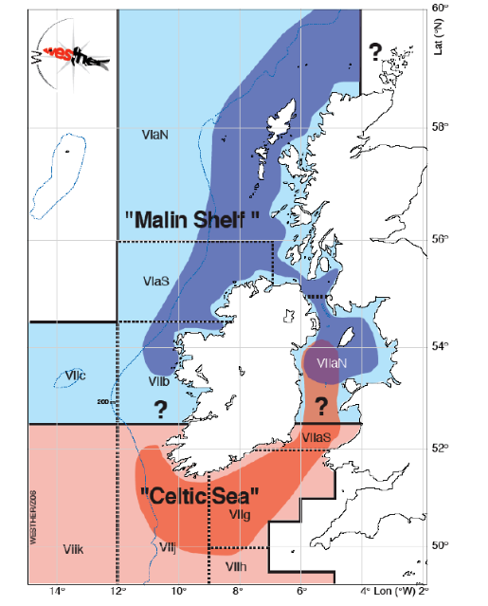
Figure 1. Fisheries and populations to the west of the British Isles.

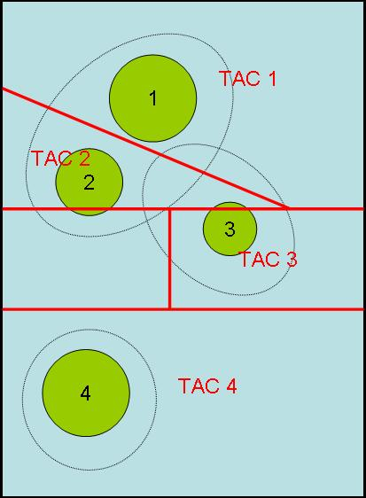

Figure 2. Diagrammatic representation of the mixing hypotheses where green circles represent spawning aggregation, dotted regions the overlap area during feeding times and red lines the assessment management units.

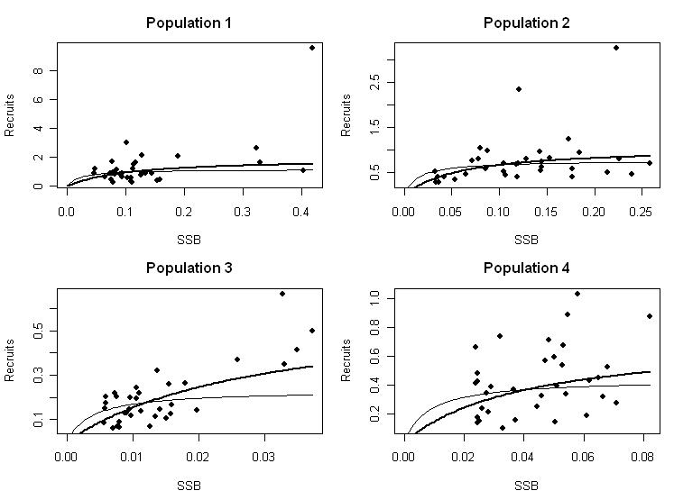
Figure 3. Stock and recruit data with Beverton and Holt functional forms with steepness of 0.75 (thick line) and 0.9 (thin line).

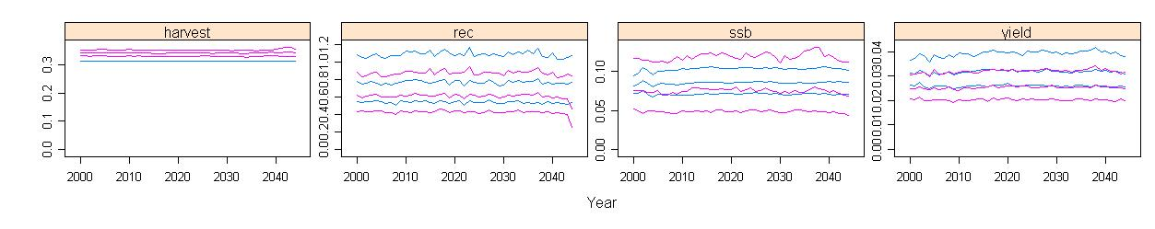
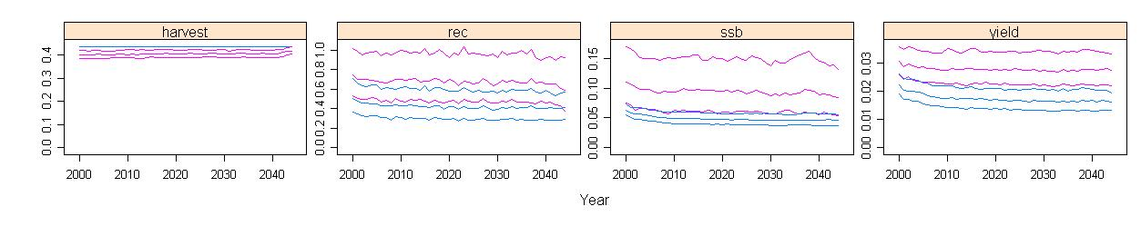
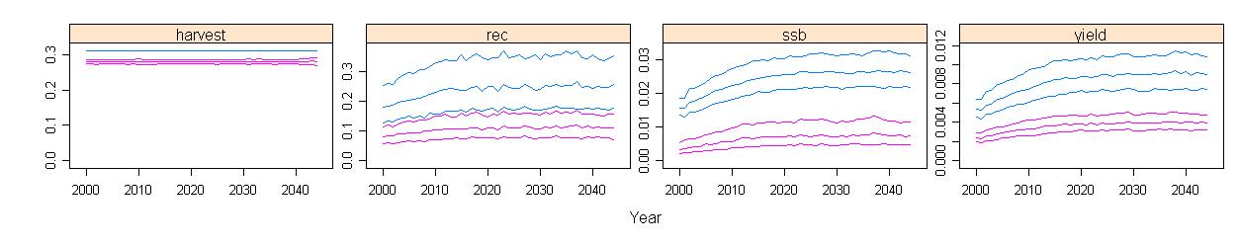
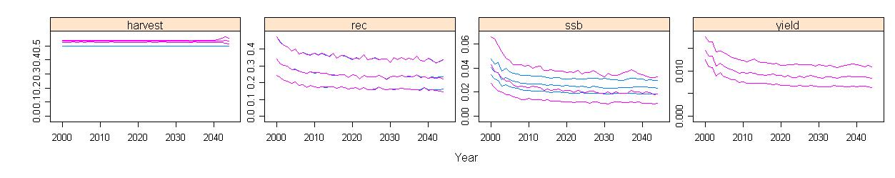
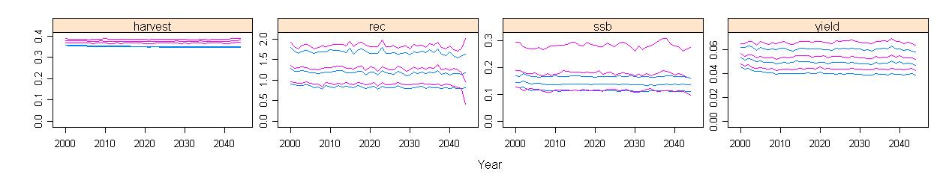
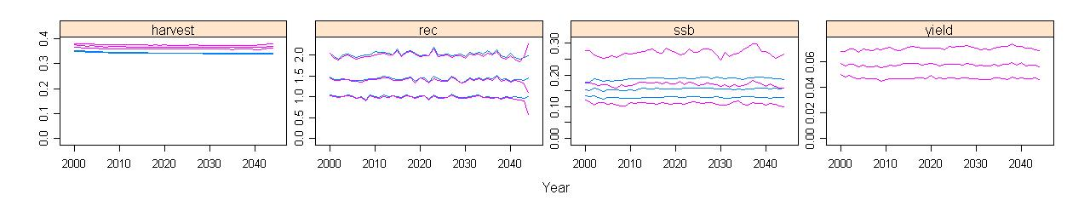
Figure 4. Evolution of populations under constant fishing mortality. First four rows correspond to populations/stocks 1, 2, 3 and 4 respectively, and rows 5 and 6 to lumping populations/stocks 1 & 2 and 1, 2 & 3. The time series show the inter-quartiles and medians for the spawning populations (blue) and VPA estimates (pink) ,based on catches from the fishery. Fishing mortality for populations 1 & 3 = 0.25, for 2 & 4 = 0.5. Survey undertaken at spawning time, no diffusion occurring.

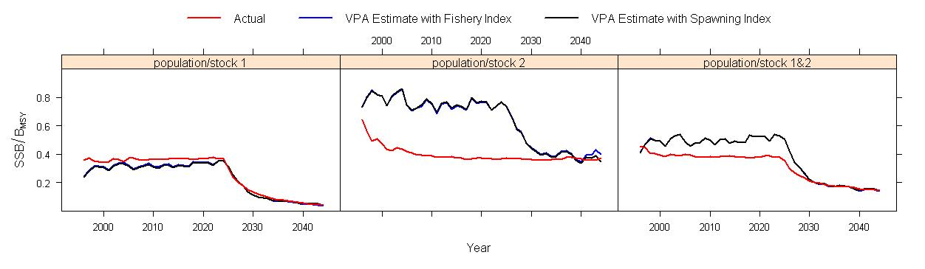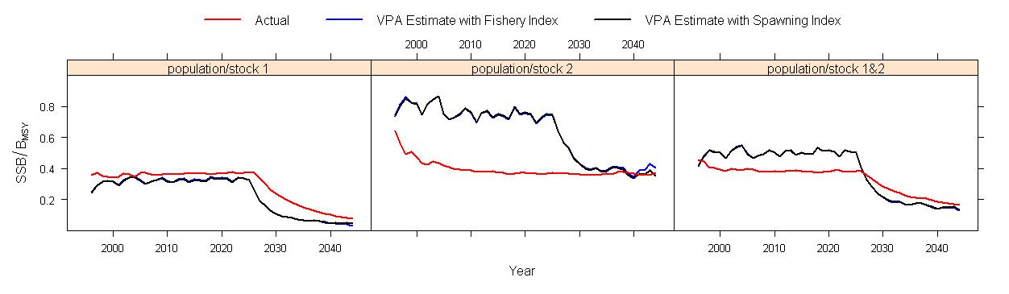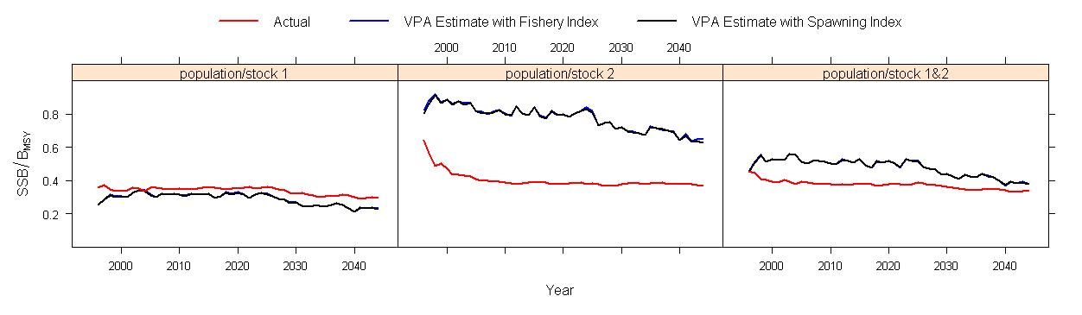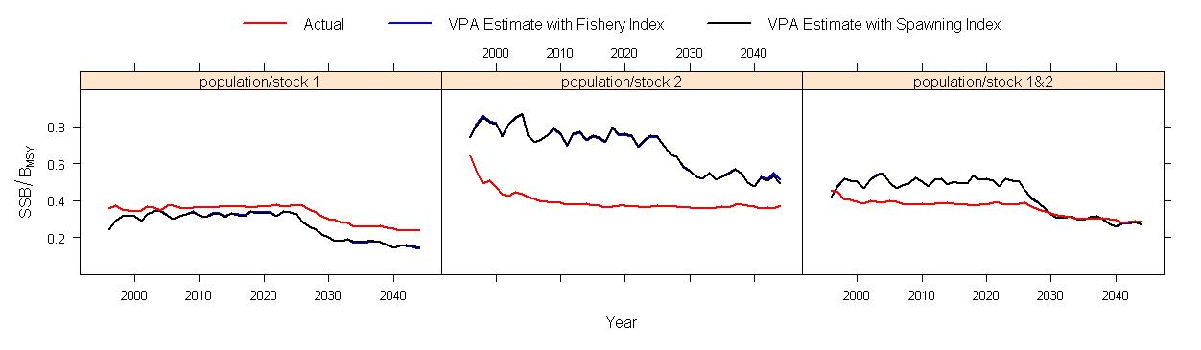

Figure 5. Time series of expected values (medians) of spawning stock biomass in the spawning population (red) and estimates from VPA of the catches from the fisheries (black and blue correspond to analysis performed using an index of abundance from the spawning population and the fishery respectively).

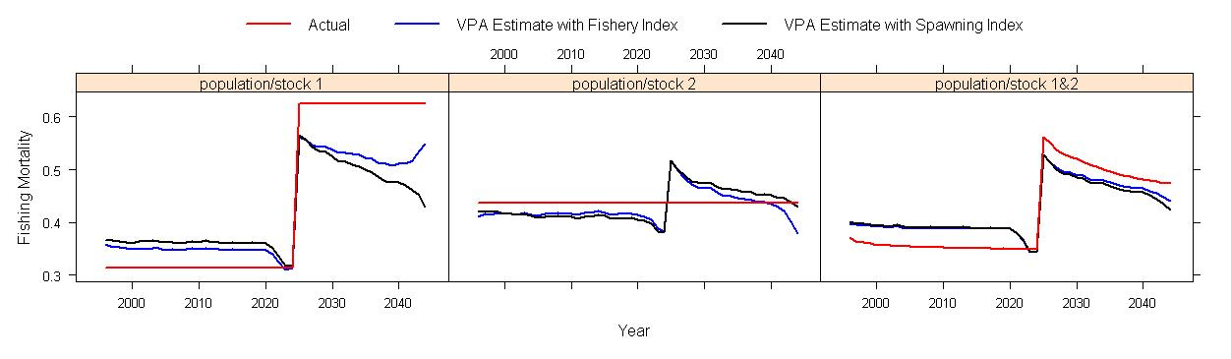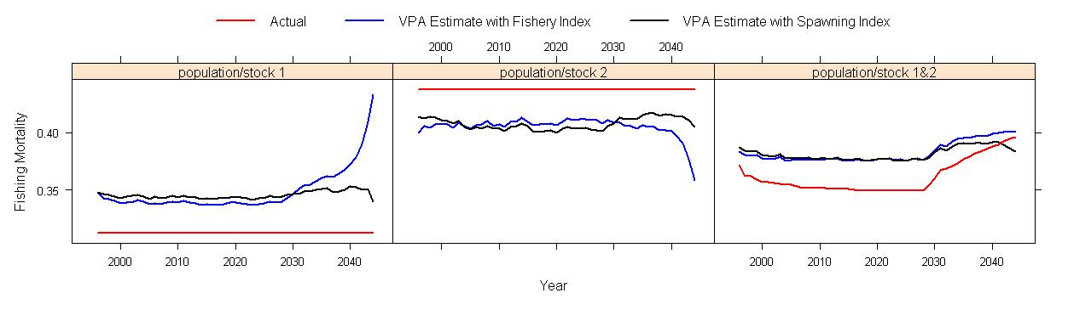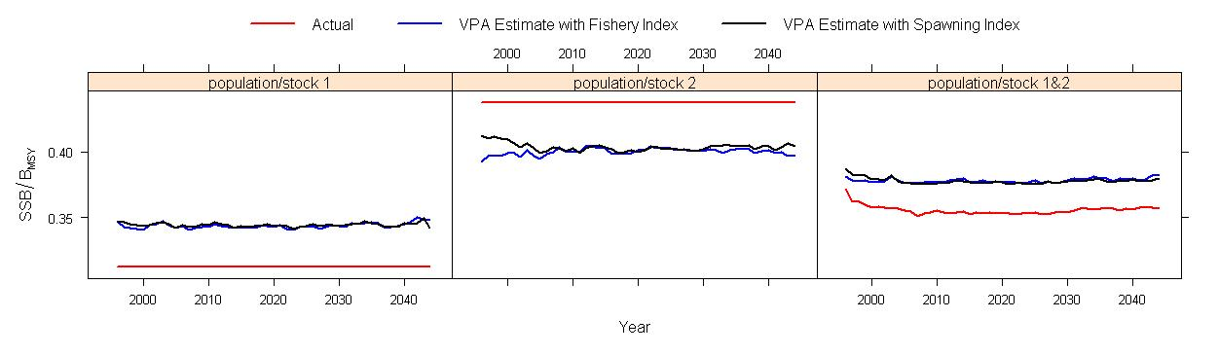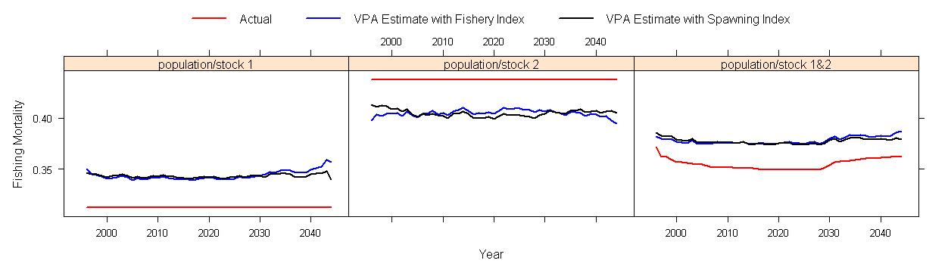
Figure 6. Time series of expected values (medians) of fishing mortality in the spawning population (red) and estimates from VPA of the catches from the fisheries (black and blue correspond to analysis performed using an index of abundance from the spawning population and the fishery respectively).

Tables

Table 1. Availability of population by fishery

Fishery 1 |  |  |  |  |  | Fishery 2
 | Availability of Population to Fishery |  |  |  |  |  | Availability of Population to Fishery
Age | 1 | 2 | 3 | 4 |  | Age | 1 | 2 | 3 | 4
1 | 75% | 25% | 25% | 0% |  | 1 | 25% | 75% | 25.0% | 0%
2 | 75% | 25% | 25% | 0% |  | 2 | 25% | 75% | 25.0% | 0%
3 | 75% | 25% | 25% | 0% |  | 3 | 25% | 75% | 25.0% | 0%
4 | 75% | 25% | 25% | 0% |  | 4 | 25% | 75% | 25.0% | 0%
5 | 75% | 25% | 25% | 0% |  | 5 | 25% | 75% | 25.0% | 0%
6 | 75% | 25% | 25% | 0% |  | 6 | 25% | 75% | 25.0% | 0%
7 | 75% | 25% | 25% | 0% |  | 7 | 25% | 75% | 25.0% | 0%
8 | 75% | 25% | 25% | 0% |  | 8 | 25% | 75% | 25.0% | 0%
9 | 75% | 25% | 25% | 0% |  | 9 | 25% | 75% | 25.0% | 0%
Fishery 3 |  |  |  |  |  | Fishery 4
 | Availability of Population to Fishery |  |  |  |  |  | Availability of Population to Fishery
Age | 1 | 2 | 3 | 4 |  | Age | 1 | 2 | 3 | 4
1 | 0.0% | 0.0% | 50% | 0% |  | 1 | 0.0% | 0.0% | 0.0% | 100%
2 | 0.0% | 0.0% | 50% | 0% |  | 2 | 0.0% | 0.0% | 0.0% | 100%
3 | 0.0% | 0.0% | 50% | 0% |  | 3 | 0.0% | 0.0% | 0.0% | 100%
4 | 0.0% | 0.0% | 50% | 0% |  | 4 | 0.0% | 0.0% | 0.0% | 100%
5 | 0.0% | 0.0% | 50% | 0% |  | 5 | 0.0% | 0.0% | 0.0% | 100%
6 | 0.0% | 0.0% | 50% | 0% |  | 6 | 0.0% | 0.0% | 0.0% | 100%
7 | 0.0% | 0.0% | 50% | 0% |  | 7 | 0.0% | 0.0% | 0.0% | 100%
8 | 0.0% | 0.0% | 50% | 0% |  | 8 | 0.0% | 0.0% | 0.0% | 100%
9 | 0.0% | 0.0% | 50% | 0% |  | 9 | 0.0% | 0.0% | 0.0% | 100%

Table 2. Diffusion between populations under the diffusion hypothesis
Population 1 |  |  |  |  |  | Population 2
 | Diffusion between populations |  |  |  |  |  | Diffusion between populations
Age | 1 | 2 | 3 | 4 |  | Age | 1 | 2 | 3 | 4
1 | 95% | 2.5% | 2.5% | 0% |  | 1 | 2.5% | 95% | 2.5% | 0%
2 | 95% | 2.5% | 2.5% | 0% |  | 2 | 2.5% | 95% | 2.5% | 0%
3 | 95% | 2.5% | 2.5% | 0% |  | 3 | 2.5% | 95% | 2.5% | 0%
4 | 95% | 2.5% | 2.5% | 0% |  | 4 | 2.5% | 95% | 2.5% | 0%
5 | 95% | 2.5% | 2.5% | 0% |  | 5 | 2.5% | 95% | 2.5% | 0%
6 | 95% | 2.5% | 2.5% | 0% |  | 6 | 2.5% | 95% | 2.5% | 0%
7 | 95% | 2.5% | 2.5% | 0% |  | 7 | 2.5% | 95% | 2.5% | 0%
8 | 95% | 2.5% | 2.5% | 0% |  | 8 | 2.5% | 95% | 2.5% | 0%
9 | 95% | 2.5% | 2.5% | 0% |  | 9 | 2.5% | 95% | 2.5% | 0%
Population 3 |  |  |  |  |  | Population 4
 | Diffusion between populations |  |  |  |  |  | Diffusion between populations
Age | 1 | 2 | 3 | 4 |  | Age | 1 | 2 | 3 | 4
1 | 2.5% | 2.5% | 75% | 20% |  | 1 | 0% | 0% | 0% | 80%
2 | 2.5% | 2.5% | 85% | 10% |  | 2 | 0% | 0% | 0% | 90%
3 | 2.5% | 2.5% | 95% | 0% |  | 3 | 0% | 0% | 0% | 100%
4 | 2.5% | 2.5% | 95% | 0% |  | 4 | 0% | 0% | 0% | 100%
5 | 2.5% | 2.5% | 95% | 0% |  | 5 | 0% | 0% | 0% | 100%
6 | 2.5% | 2.5% | 95% | 0% |  | 6 | 0% | 0% | 0% | 100%
7 | 2.5% | 2.5% | 95% | 0% |  | 7 | 0% | 0% | 0% | 100%
8 | 2.5% | 2.5% | 95% | 0% |  | 8 | 0% | 0% | 0% | 100%
9 | 2.5% | 2.5% | 95% | 0% |  | 9 | 0% | 0% | 0% | 100%

Table 3. Reference points

Population | Steepness | F_{MSY} | MSY | B_{MSY} | F_{Crash}
1 | 0.75 | 0.15 | 0.05 | 0.27 | 0.49
2 | 0.75 | 0.21 | 0.03 | 0.16 | 1.23
3 | 0.75 | 0.16 | 0.02 | 0.08 | 0.65
4 | 0.75 | 0.22 | 0.02 | 0.11 | 1.46

Table 4. Selected scenarios
Scenario | Fishing Mortality |  |  |  | Increase  In F | Regime  Shift | SRR steepness | Diffusion
 | 1 | 2 | 3 | 4
1 | 0.25 | 0.5 | 0.25 | 0.5 | None | None | 0.75 | No
2 | 0.25 | 0.5 | 0.25 | 0.5 | Fishery 1 | None | 0.75 | No
3 | 0.25 | 0.5 | 0.25 | 0.5 | None | F_{MSY} | 0.75 | No
4 | 0.25 | 0.5 | 0.25 | 0.5 | None | F_{MSY} | 0.75 | Yes
5 | 0.25 | 0.5 | 0.25 | 0.5 | None | B_{MSY} | 0.75 | No

